
Company
Logotype

Cone Beam Computed Tomography- Report



Porur Dental X-rays & CBCT

Patient Name : Miss. Bhuvaneshwari | Date of Report : 08.07.2024
Age/ Gender : 27 years/ Female | Region of Interest : CBCT Full Skull
Referring doctor: SRMDC | Indication : Implant assessment
Clinical Notes: Nil
PATIENT INFORMATION

CBCT- Full Skull provided
CBCT – IMAGE DETAILS

RADIOGRAPHIC INTERPRETATION

- Completely missing crown and root portion in relation to 18, 26, 27, 28, 36, 37, 38, 46, 47, 48.
- The alveolar ridge in relation to the maxillary and mandibular alveolar ridge are present with normal trabecular pattern.

IMPLANT ASSESSMENT

 | 26 region | 27 region
Sub-Crestal (in mm) | 8 | 12.8
Mid- Crestal (in mm) | 8.7 | 13.5
Distance between the alveolar ridge and floor of the maxillary sinus (in mm) | 8.9 | 8.2

 | 36 region | 37 region
Sub-Crestal (in mm) | 3.7 | 6.6
Mid- Crestal (in mm) | 4.5 | 8.8
Distance between alveolar ridge and the inferior alveolar nerve canal (in mm) | 15.6 | 16.1
Distance between alveolar ridge and the inferior border of mandible (in mm) | 24.5 | 24.7

 | 46 region | 47 region
Sub-Crestal (in mm) | 4.9 | 5.6
Mid- Crestal (in mm) | 6.1 | 8.1
Distance between alveolar ridge and the inferior alveolar nerve canal (in mm) | 15.4 | 14.1
Distance between alveolar ridge and the inferior border of mandible (in mm) | 24.2 | 22.7

RADIOGRAPHIC IMPRESSION

- Partially edentulous maxillary and mandibular arch.

Kindly correlate with clinical findings


IMAGES FOR REFERENCE

RECONSTRUCTED PANORAMIC VIEW
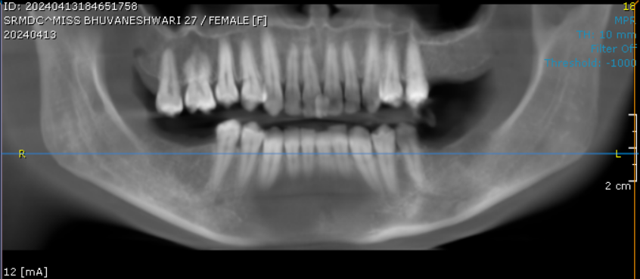

3-DIMENSIONAL VIEW

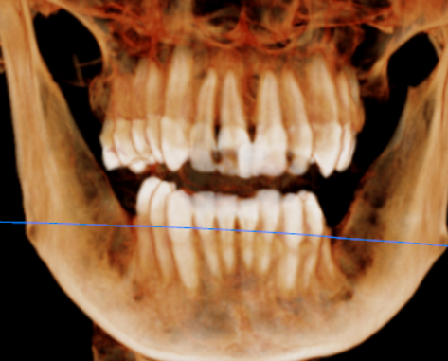

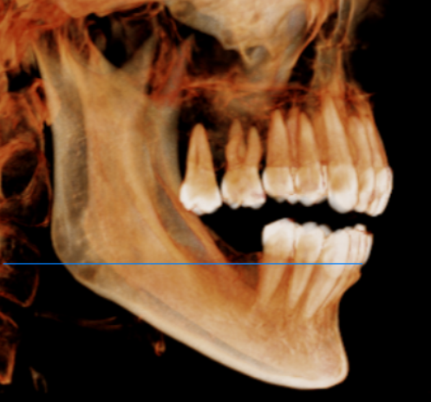
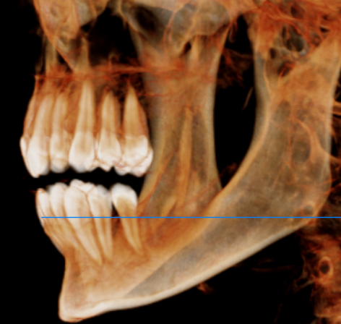

CROSS SECTIONAL VIEW

26 region | 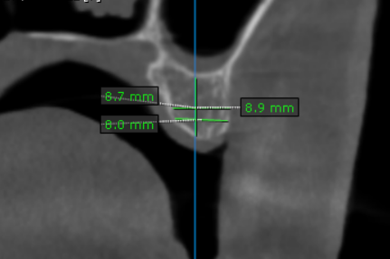
27 region | 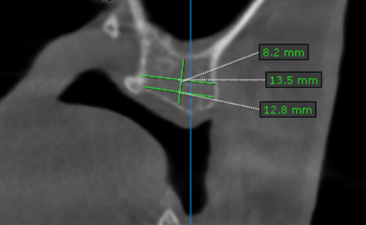
36 region | 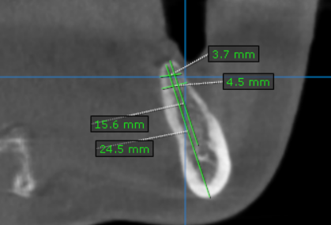
37 region | 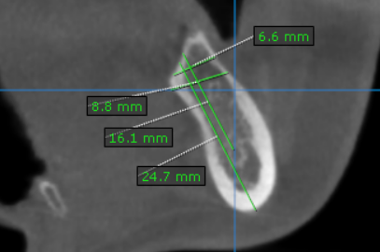
46 region | 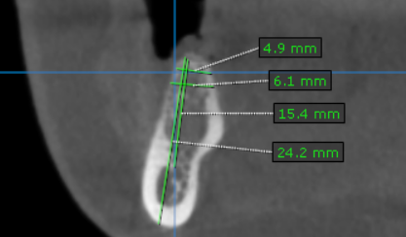
47 region | 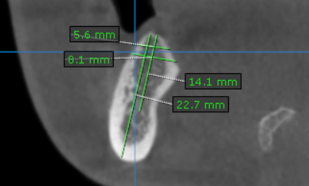

**** End of report ****

